**FPT ACADEMY INTERNATIONAL**



## FPT – APTECH COMPUTER EDUCATION

Sky Gazing

|  |  |  |  |
| --- | --- | --- | --- |
| **Center Name** | | FPT – Aptech – HCM2  Address: 590 Cach Mang Thang Tam, District 3, Ho Chi Minh City | |
| **Instructor** |  | Mr. Nguyen Phat Tai |  |
| **Class** |  | T1.2206.E1 |  |
| **Group** |  | 6 |  |
| **Group members** | | **Name** | **Student ID** |
|  |  | Tran Hoang Tu | Student1387806 |
|  |  | Nguyen Dinh Nam | Student1387823 |
|  |  | Tran Le Huy | Student1387805 |
| **Duration** | Start date | 15 th Septemper 2022 |  |
| End date | 15th October 2022 |  |

**This is to certify that**

**Mr.:**

Tran Hoang Tu

Nguyen Dinh Nam

Tran Le Huy

**Has successfully designed & developed**

eProject: Sky Gazing

**Submitted by: Tran Hoang Tu**

**Date of issue: 15-Sep-2022**

**Authorized Signature:Tu**



**TABLE OF CONTENTS**

FPT – APTECH COMPUTER EDUCATION 1

ACKNOWLEGMENT 4

SYNOSIS 4

PROBLEM DEFINITION 4

CUSTOMER'S REQUIREMENTS SPECIFICATIONS (CRS) 5

Business/Project Objective: 5

Hardware/ Software Requirements: 7

SCOPE OF THE WORK (IN BRIEF) 8

Architecture and design of the system 9

Diagram of the website 10

TASK SHEET REVIEW 1 10

SITE MAP 11

MOCK OF THE WEBSITE 12

1.HOMEPAGE 12

2.PLANET 13

3.STAR 14

4.NEWS 15

5.OBSERVATORIES 16

6.GALLERY 17

7.SITE MAP 18

8.ABOUT US 19

9.CONTACT US 20

TASK SHEET REVIEW 2 21

WEBSITE DESCRIPTION 22

HOMEPAGE 22

Description 22

PLANET 23

Description: 23

STAR 24

NEWS 26

OBSERVATORIES 28

Gallery 29

SITEMAP 30

ABOUT US 31

CONTACT US 32

Source Code of HTML, CSS, JavaScript and Angular JS 33

HTML: 33

CSS: 34

JSON: 35

JS: 36

TASK SHEET REVIEW 3 37

# ACKNOWLEGMENT

On behalf of all the members of group 1, I would like to thank you all for the hard works, supports to make this eProject complete successfully. Especially, Mr. Nguyen Phat Tai, our teacher, he helped us a lot from the day that we started to study at FPT Aptech. With this eProject, he has guided us with his enthusiasm and rigorous, because of his guiding, we would be able to finish this project. Besides, I want to thank all the team member of group 1, each of the team members has been working continuously in 4 weeks in order to complete this project. The last but not least, we would like to say thank you to our family for always supporting us, creating the best conditions for us to focus on the project, and putting faith in the dreams we pursue.

# SYNOSIS

We want to create a website for young people to be more exposed to sky gaze. For those who love the stars, planets and wonders of this galaxy. We have searched from many sources to be able to provide the most current and accurate information to everyone.

# PROBLEM DEFINITION

The Web site is to be created based on the following requirements.

1. The web page should have the description/images about various planets. If user clicks on the same, navigational link must be available.
2. There should be categories providing details about Solar Eclipse, big bang theory, evolution of earth etc
3. Various sections such as –
   1. When best to Star Gaze
   2. Where is best to Star Gaze
   3. What to expect to see in a Star Gaze
4. The site should also list and explain various planets available as well as details about them as
   1. When discovered
   2. Size
   3. Atmosphere there
   4. Distance from sun and earth
   5. Other available important details about them.
5. There should be information on constellations as what is it/how it is formed and various constellations.
6. There should also be a section on comet giving information related.
7. Also include a section which will provide details on various latest developments in the field of astronomy related to planets and stars.
8. List of Few top Observatories with details and location displayed using GeoLocation API (eg. GoogleMaps).
9. Site map, Gallery, About us, Contact us link must be added.
10. About Us and Contact Us: This menu option should display Email id, address, and contact number of Sky Gazing Company.

# CUSTOMER'S REQUIREMENTS SPECIFICATIONS (CRS)

**Client: Sky Gazing**

### Business/Project Objective:

The sky is full of possibilities and experiences, why not chase them all?

The sun, moon, stars, and planets have been a source of wonder for as long as humans have lived on earth.

We are here looking at a website which will provide brief details about few facts and details about astronomy

The website is supposed to provide user friendly environment and navigation. The important menu must be stated in the top section of the webpage. Also a decent look out and color combination is expected

You are supposed to create a Single-Page-Application and responsive Website for them with the below mentioned requirement specifications.

The website is to be developed for the Windows Platform using HTML5, JSON, Angular JS, JavaScript and Geolocation. The site should work well in all leading browsers including Chrome, IE, Firefox etc.

**Input to the system:**

- Searching for names of planets, stars, events, ..etc

**Output from the system:**

* A menu that will categorize all the functions of the site.
* Display the list of available albums category wisely.
* Perform the search based on a particular: planets , stars , events ...etc.
* The site will provide informative / polite information about the issues you want to find out about
* The location of the observatories under Observatories-page.
* Besides the above requirements, the site should have look and feel as per the industry standards.

**Expected delivery date:** 15-Oct-2022.

**List of deliverables:**

* + - * Document Word.
      * User Guide.
      * Source code.

### Hardware/ Software Requirements:

**Hardware**

* Intel Core i3/i5 Processor or higher
* 8 GB RAM or above
* Color SVGA
* 500 GB Hard Disk space
* Mouse
* Keyboard

**Software**

Technologies to be used:

* Frontend: HTML5, CSS, Bootstrap, JavaScript, jQuery, AngularJS, XML
* Data Store: JSON files or TXT files

Other Requirements:

* Operating Portal: Windows
* Browsers: Edge, Chrome, Mozilla Firefox, Safari

# SCOPE OF THE WORK (IN BRIEF)

After a long and detailed discussion, our group has decided to create a website contain the following webpages:

1. ***Homepage***: Display information about Star Gazing , an introduction about Star Gazing.
2. ***Planets , Stars*** : Display all information of planets and starts ( characteristics , size , …)
3. ***Events*** : Give information Solar Eclipse, big bang theory, evolution of earth etc.
4. ***Achievments***: Display the information of the achievements latest .
5. ***Observatories***: Display the address of the Observatories , allow customers to request any information they want from Astronomy World.

# Architecture and design of the system

**SERVER**

**CLIENT**

Webpage request

**Angular JS**

**Java Script**



Requested Page

**RENDERING**

**ENGINE**

**CSS CODE**

**HTML CODE**

**WEB SERVER**

**WEB BROWSER**

# Diagram of the website

.

# TASK SHEET REVIEW 1

|  |  |  |  |  |  |  |  |
| --- | --- | --- | --- | --- | --- | --- | --- |
| **Project Ref. No.:**  **eP/Advertisement Portal Management**  **System/01** | | **Project Title:** | **Activity Plan Prepared By:** | **Date of Preparation of Activity Plan:** | | | |
| **Sr.**  **No.** | **Task** | **Actual**  **Start Date** | **Actual Days** | **Team**  **Mate Names** | **Status** |
| 1 | Problem Statement | Sky Gazing | Tu | 15-Sep-2022 | 1 | Tu | Completed |
| 2 | Analysis of Sky Gazing World requirements about the website | 15-Sep-2022 | 1 | Tu | Completed |
| 3 | The scope of the work (in brief) | 15-Sep-2022 | 1 | Nam | Completed |
| 4 | Architecture and design of the system | 15-Sep-2022 | 1 | Nam | Completed |
| 5 | Diagram of the website | 15-Sep-2022 | 1 | Huy | Completed |
| 6 | Task Sheet | 15-Sep-2022 | 1 | Huy | Completed |

|  |  |
| --- | --- |
| **Date:** | |
| Signature of Instructor:  **Mr. Nguyen Phat Tai** | Signature of Team Leader:  **Mr. Tran Hoang Tu** |

# SITE MAP

Sky Gaze

Contact us

About Us

Site Map

Gallery

Observatories

News

Star

Planet

Home

Comet

Constellations

Star

# MOCK OF THE WEBSITE

### **1.HOMEPAGE**

THREE STARS

THREE PLANETS

INTRODUCE

HEADER

(Navigation bar )

### 2.PLANET

IMAGE OF PLANET

CHARACTERISTICS AND STRUCTURE

INTRODUCE

HEADER

(Navigation bar )

### 3.STAR

HEADER

(Navigation bar )

IMAGE OF STAR

CHARACTERISTICS AND STRUCTURE

LIST OF STAR: STAR, CONSTELLATIONS,COMET

### 4.NEWS

IMAGE OF NEWS

LATEST NEWS

HEADER

(Navigation bar )

### 5.OBSERVATORIES

IMAGE OF OBSERVATORIES

INFOR OF OBSERVATORIES

HEADER

(Navigation bar )

### 6.GALLERY

IMAGE: STAR,PLANET

TITLE: STAR,PLANET

HEADER

(Navigation bar )

### 7.SITE MAP

LIST OF CATEGORY

HEADER

(Navigation bar )

### 8.ABOUT US

INFOR ABOUT US

HEADER

(Navigation bar )

### 9.CONTACT US

LOCATION

ADDRESS,PHONE,EMAIL

HEADER

(Navigation bar )

# TASK SHEET REVIEW 2

|  |  |  |  |  |  |  |  |
| --- | --- | --- | --- | --- | --- | --- | --- |
| **Project Ref. No.:**  **eP/Advertisement**  **Portal Management System/01** | | **Project Title:** | **Activity Plan Prepared By:** | **Date of Preparation of Activity Plan:** | | | |
| **Sr.**  **No.** | **Task** | **Actual Start Date** | **Actual Days** | **Team Mate Names** | **Status** |
| 1 | Site map | Sky Gazing | Tu | 30-Sep-22 | 1 | Tu | Completed |
| 2 | Mock of the website | 30- Sep -22 | 1 | Huy | Completed |
| 3 | Task sheet | 30- Sep -22 | 1 | Nam | Completed |

|  |  |
| --- | --- |
| **Date:** | |
| Signature of Instructor:  **Ms. Nguyen Phat Tai** | Signature of Team Leader:  **Mr. Tran Hoang Tu** |

# WEBSITE DESCRIPTION

## HOMEPAGE

Description**:**

Display following information:

* Introduce about space
* Three popular constellations
* Three popular stars

Screenshot:

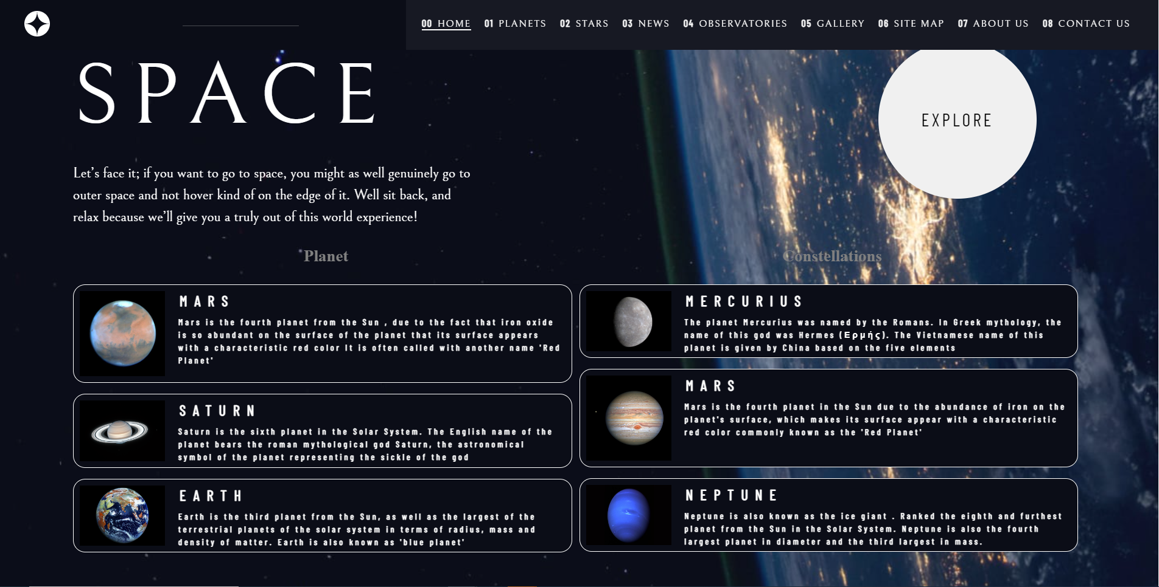

## PLANET

List and explain various planets

Description:

* When discovered
* Size
* Atmosphere there
* Distance from sun and earth
* Other available important details about them

Screenshot:

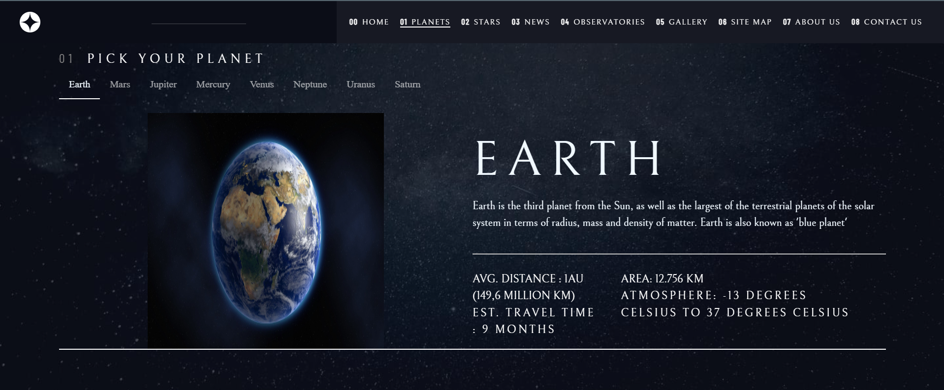

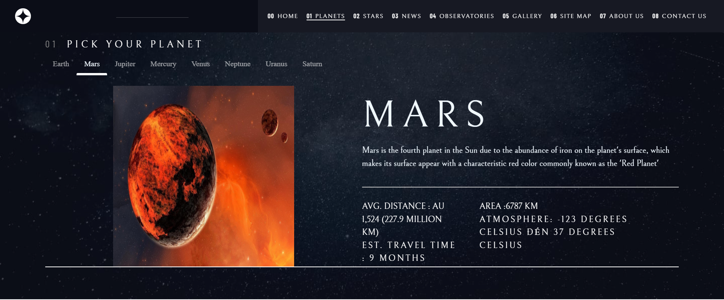

## STAR

Information of: Constellations, Definition, Comet

Description:

1. Constellations
   1. List Constellation
      1. Detail
2. Star Definition
   1. Information
3. Comet Definition
   1. Information

Screenshot:

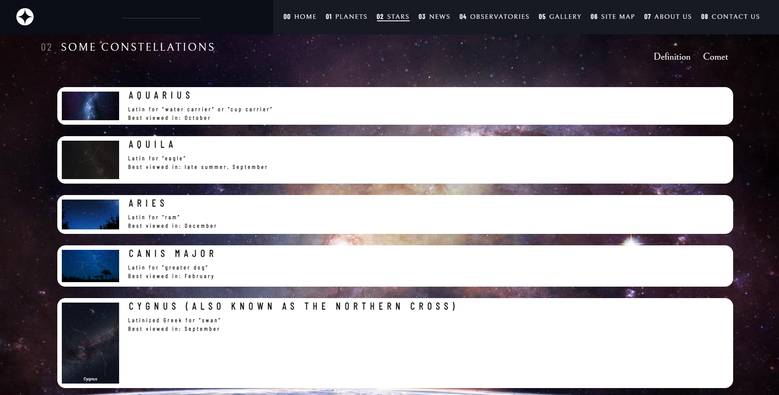

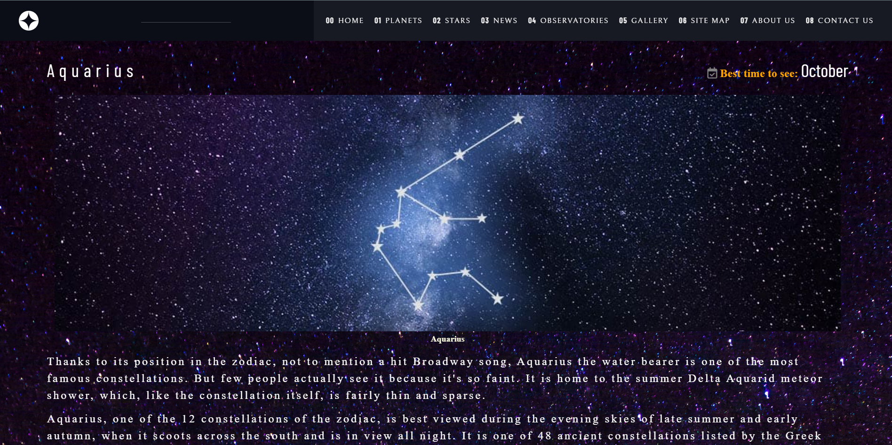

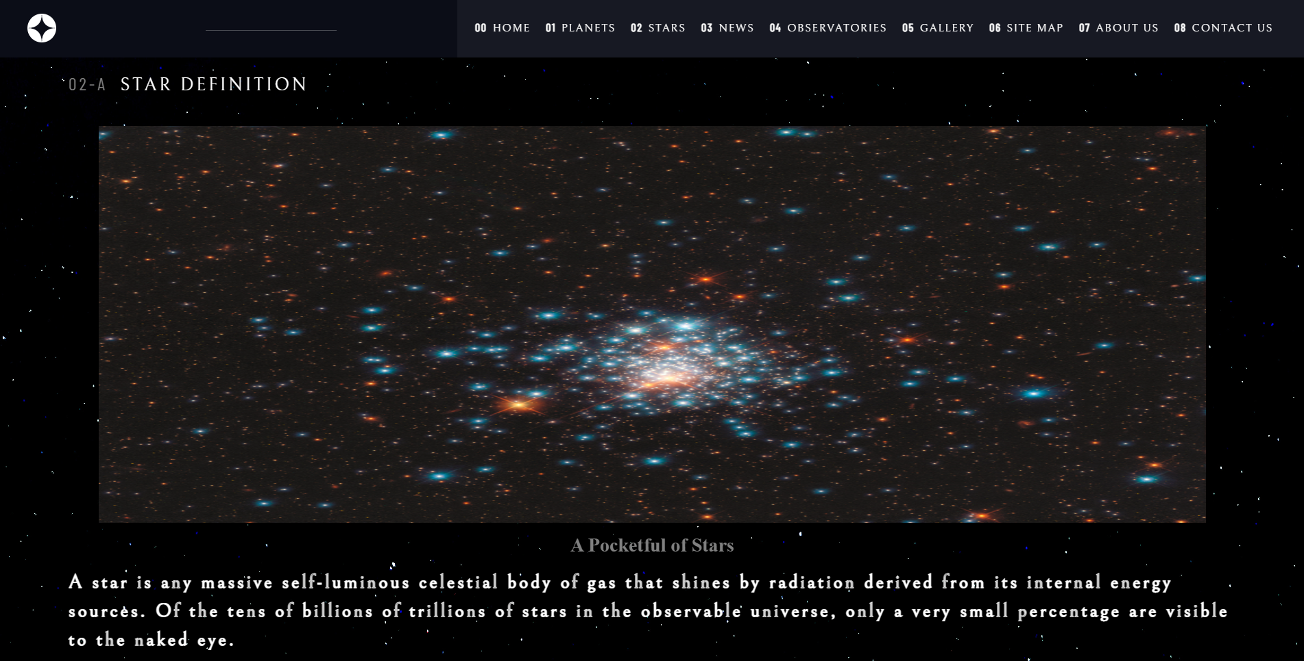

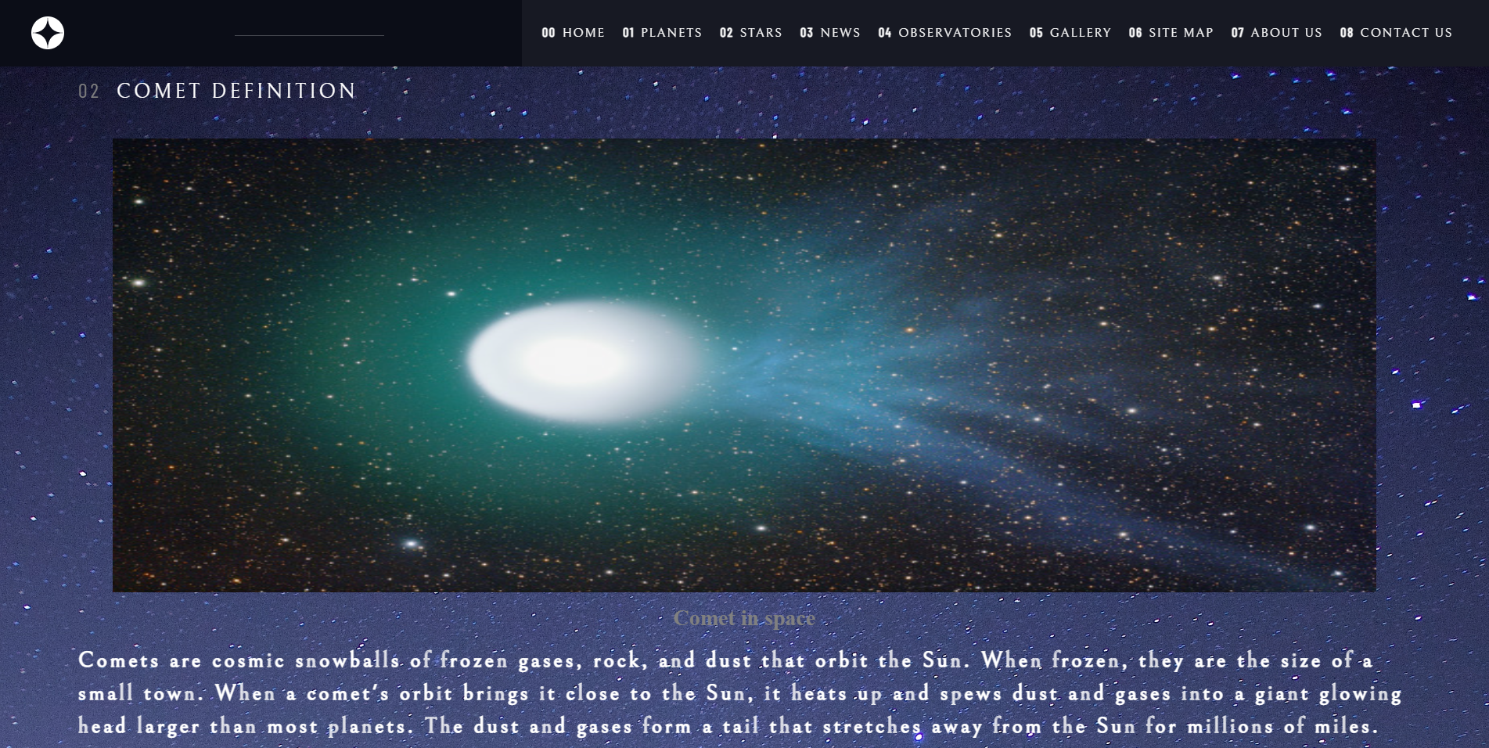

## NEWS

News list

Description:

1. News list
   1. Detail

Screenshot:

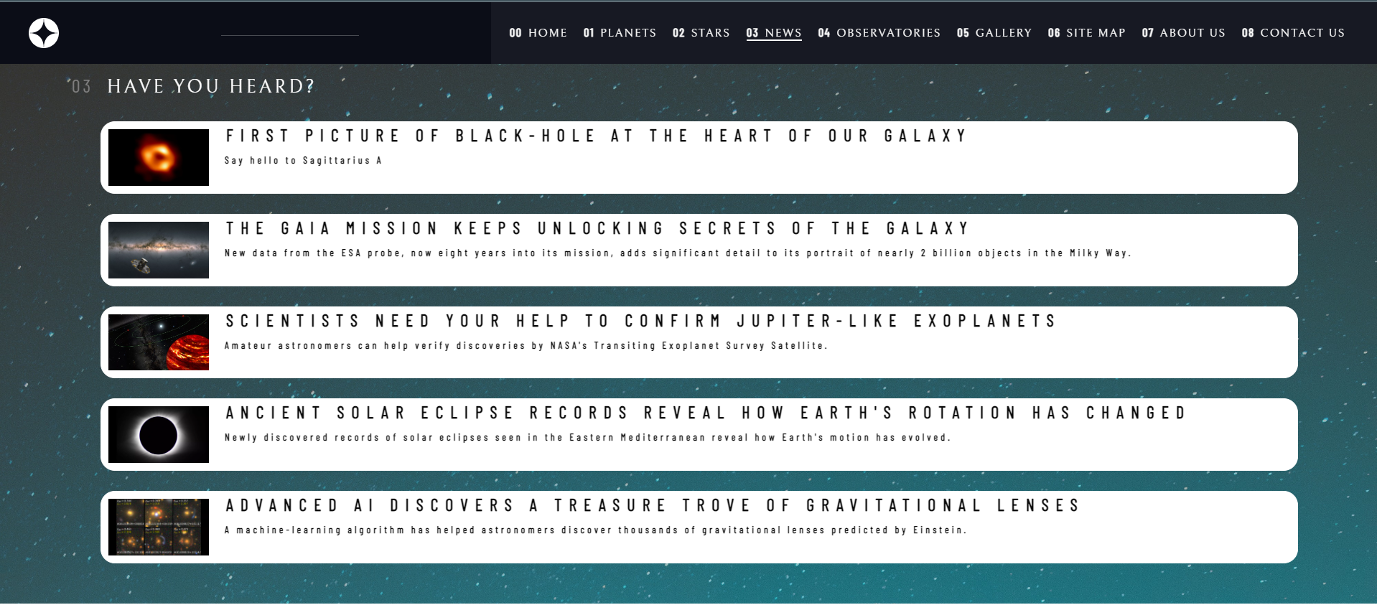

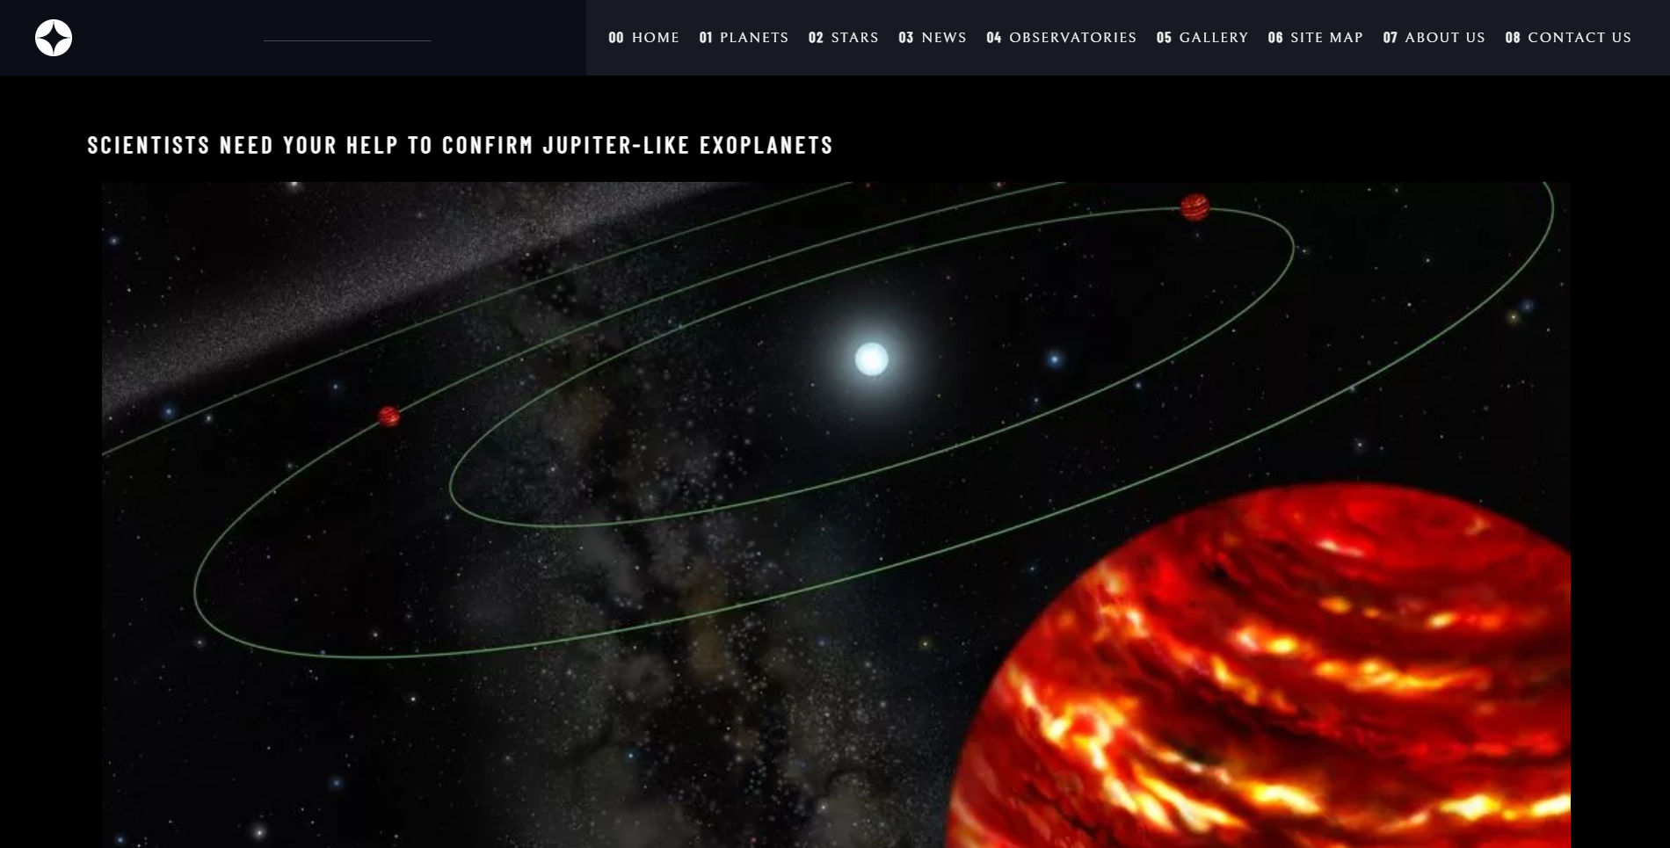

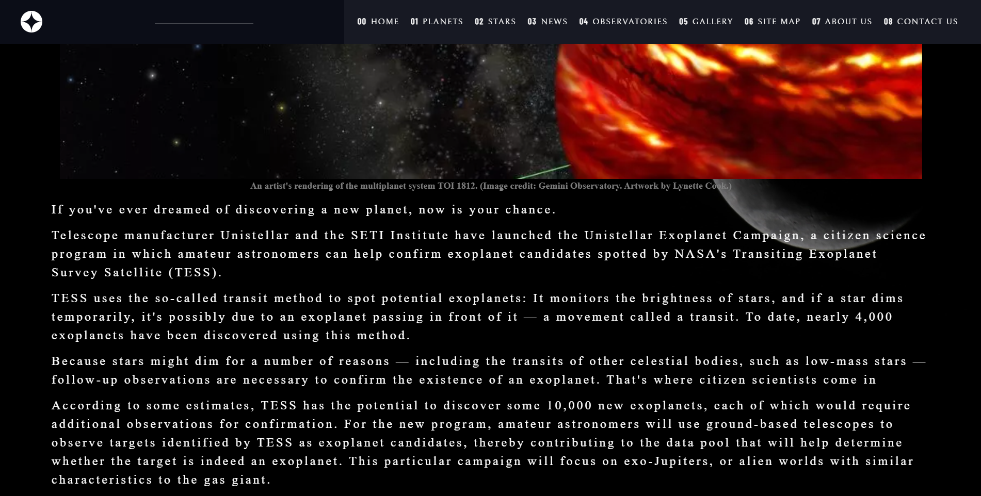

## OBSERVATORIES

List Observatories and detail about them

Description:

* List of Few top Observatories with details and location displayed

Screenshot:

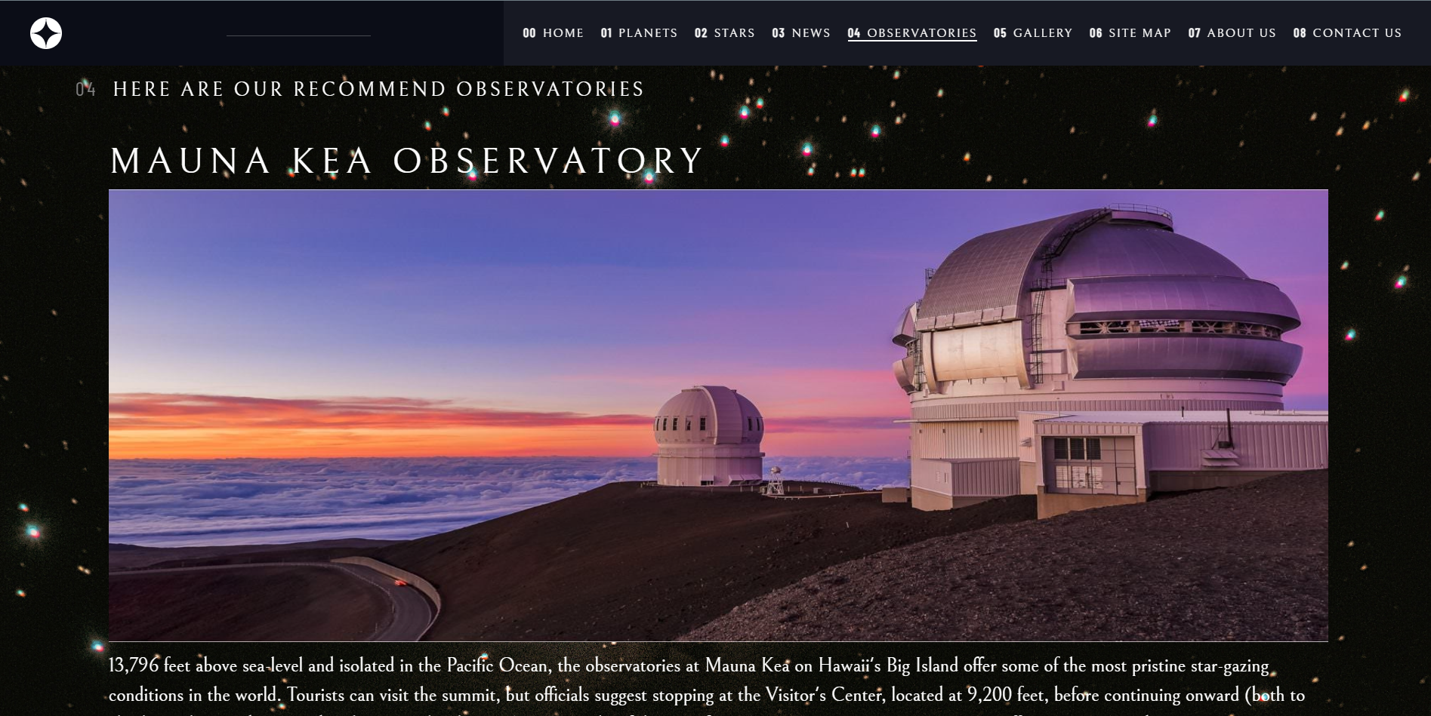

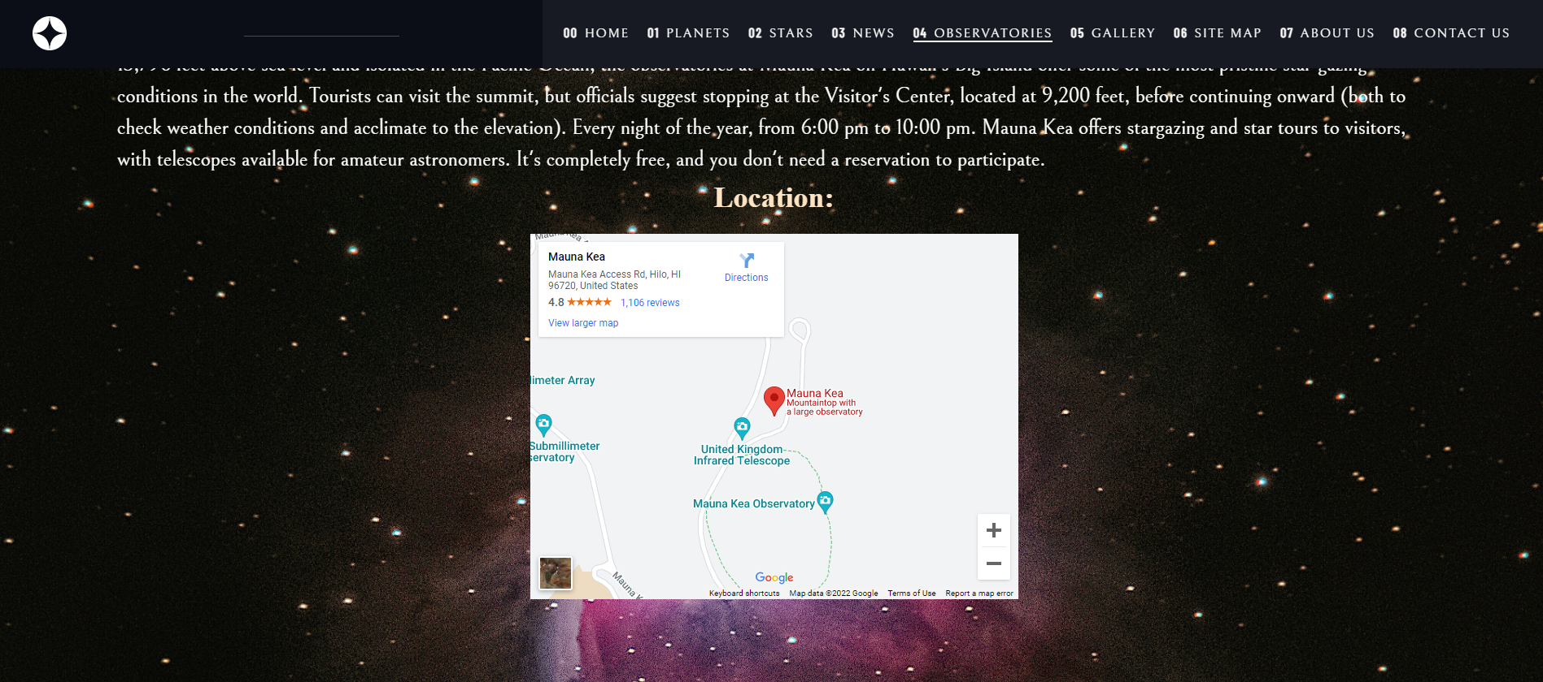

## Gallery

List images

Screetshot:

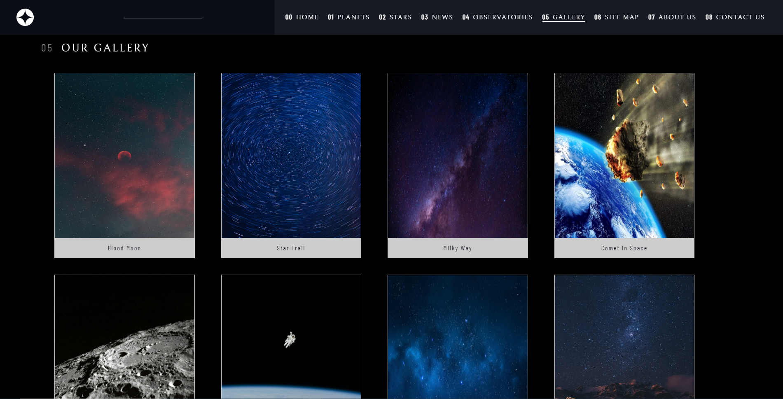

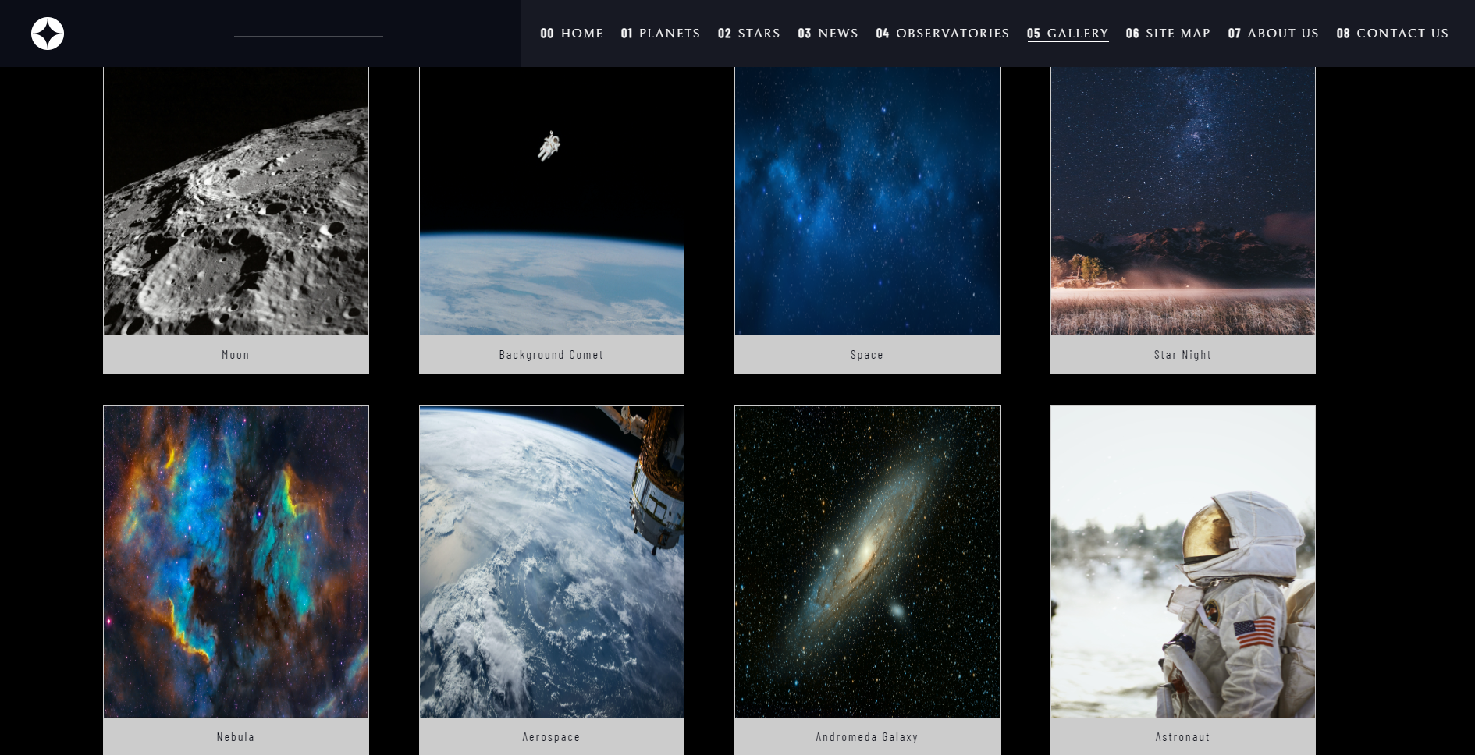

## SITEMAP

Screetshot:

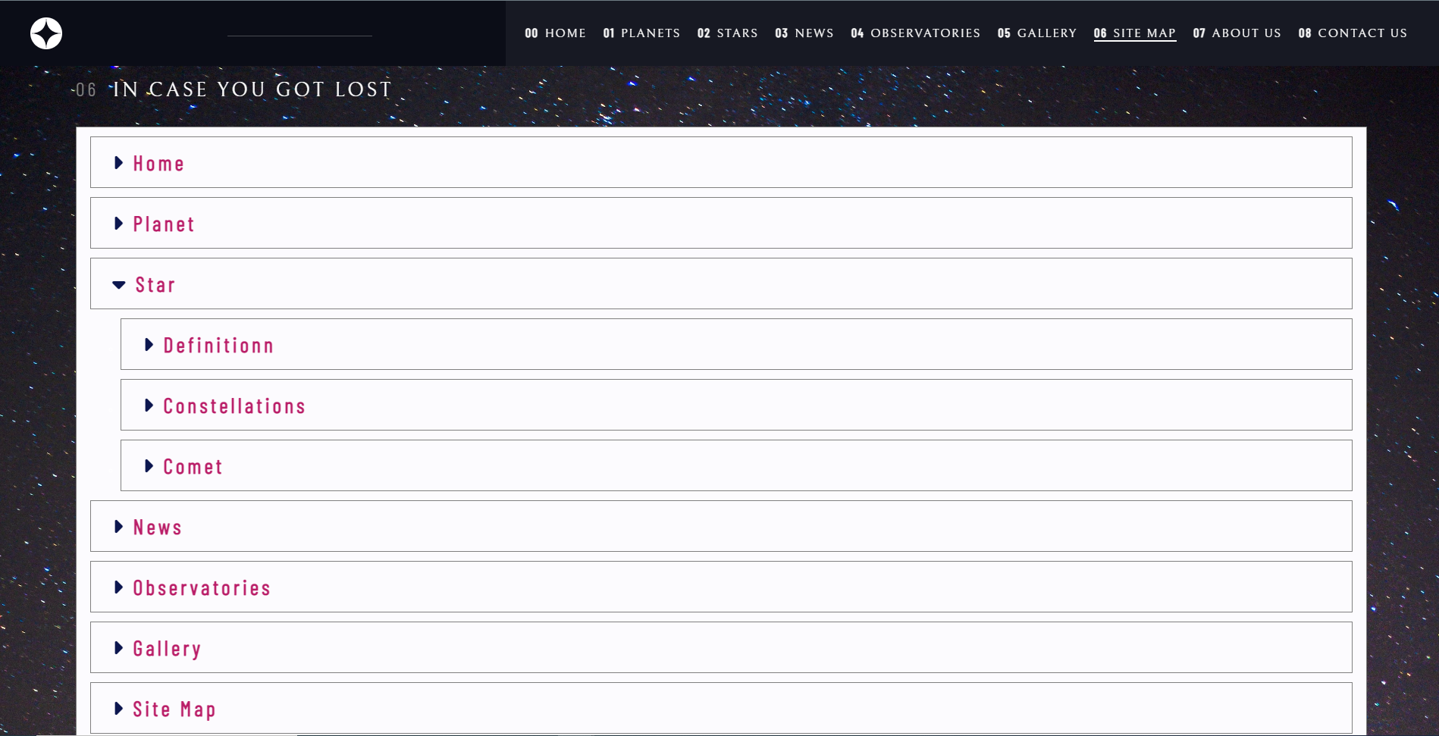

## ABOUT US

Information of project members

Screetshot:

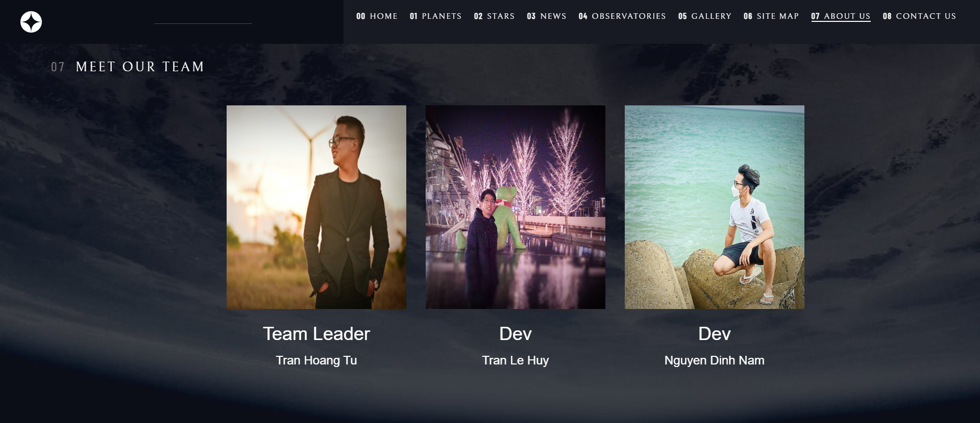

## CONTACT US

Screetshot:

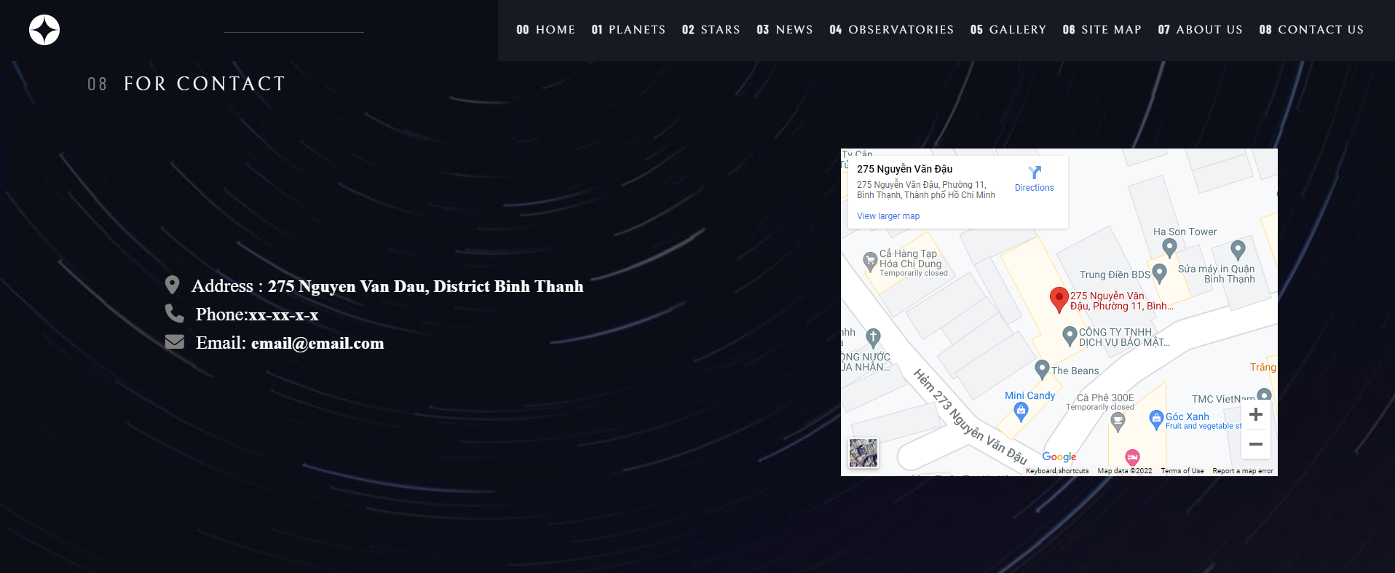

# Source Code of HTML, CSS, JavaScript and Angular JS

## HTML:

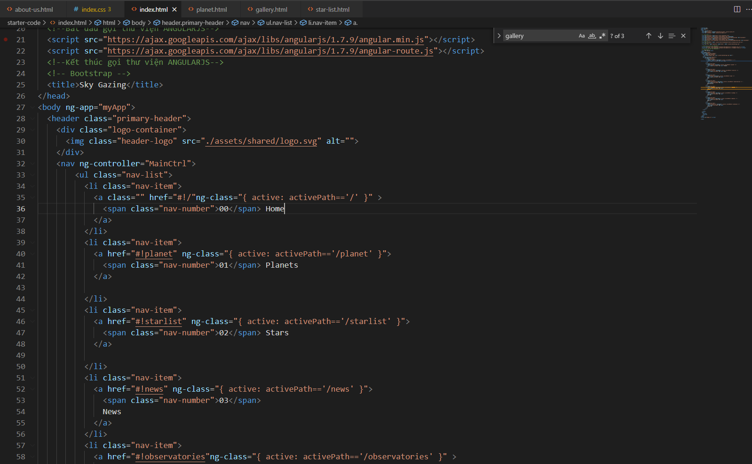

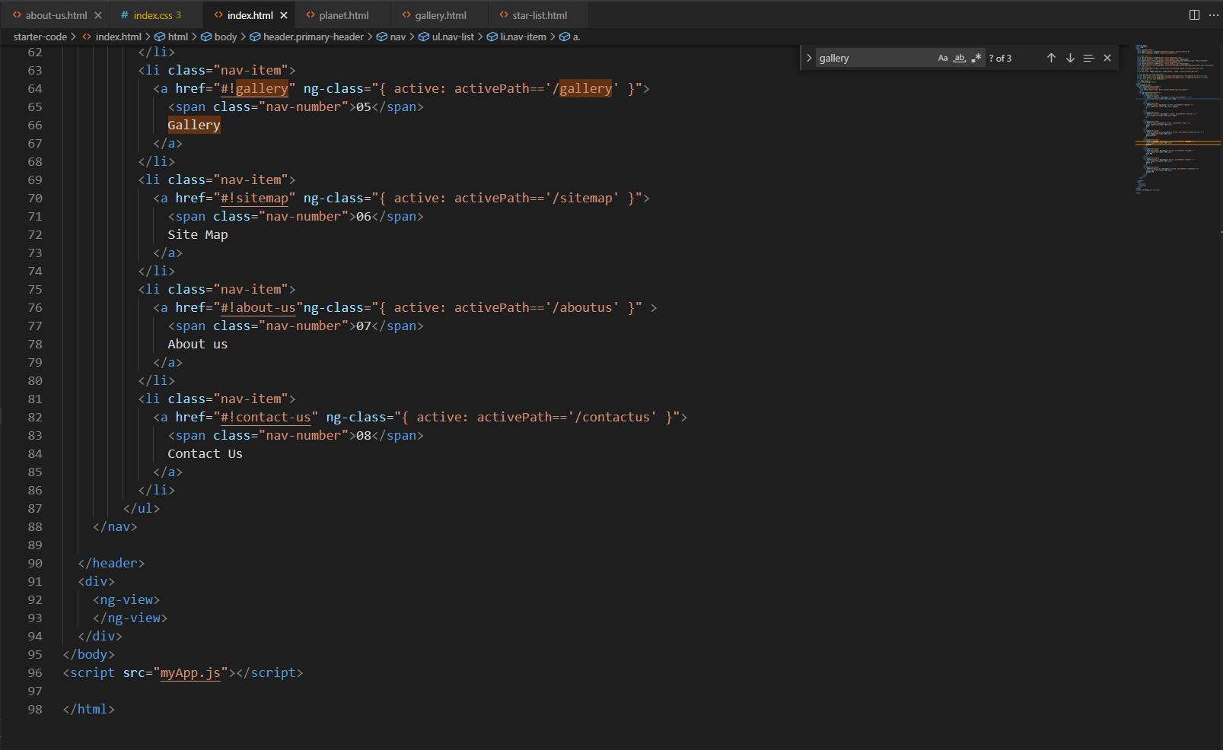

## CSS:

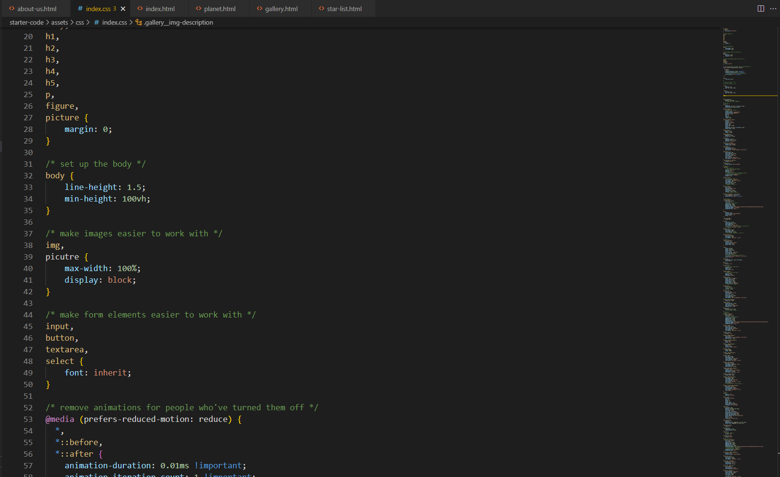

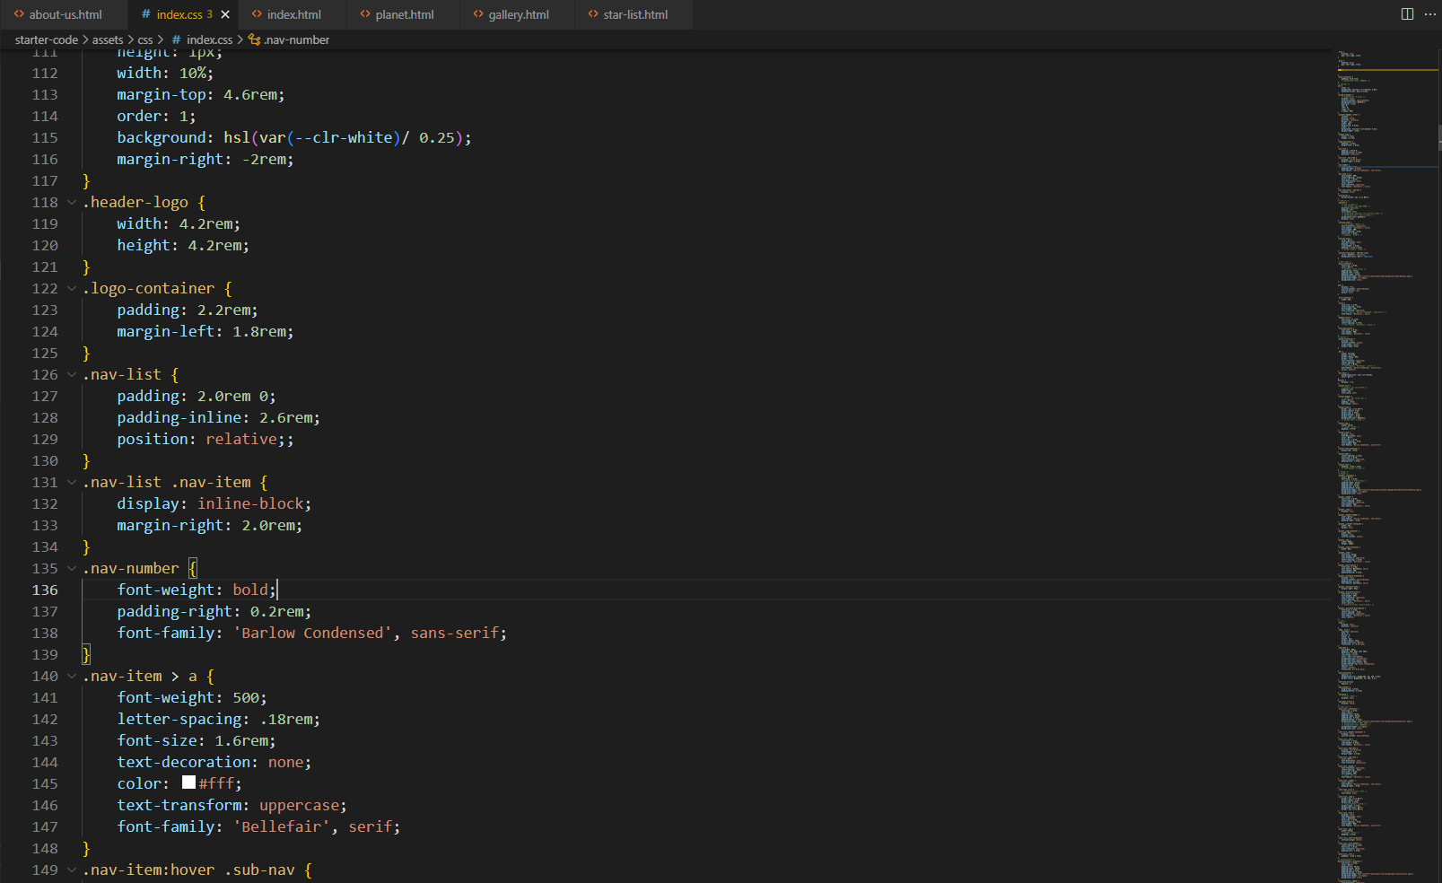

## JSON:

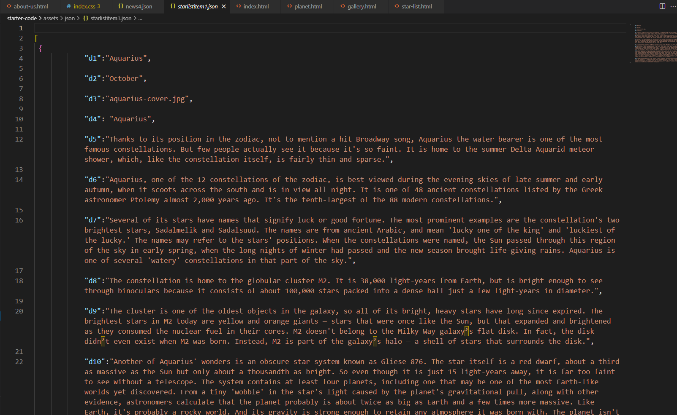

## JS:

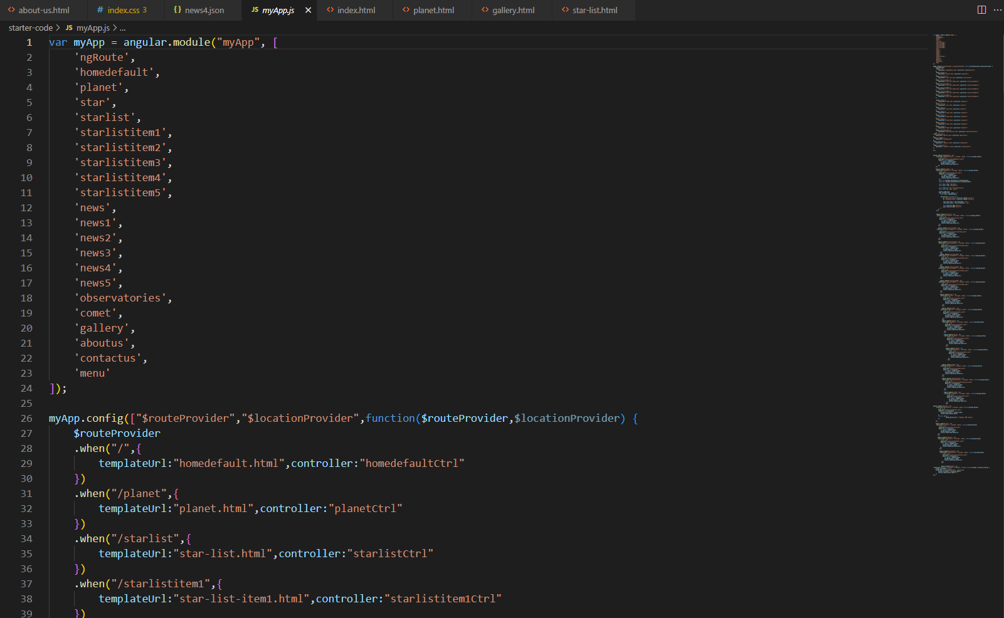

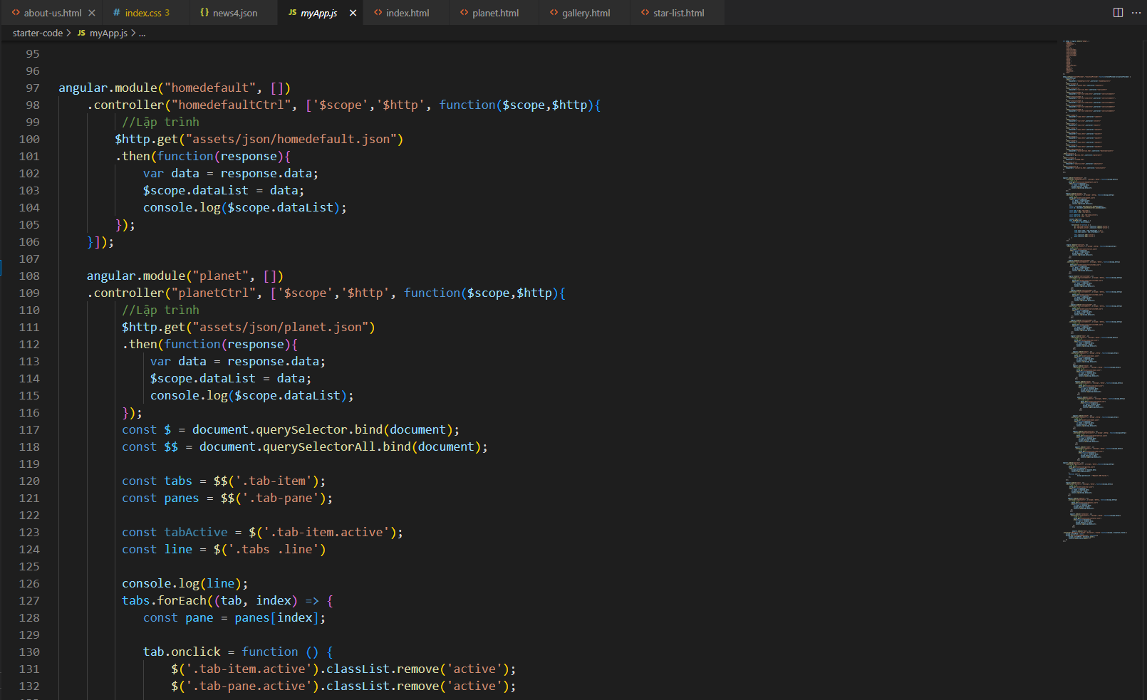

# TASK SHEET REVIEW 3

|  |  |  |  |  |  |  |  |
| --- | --- | --- | --- | --- | --- | --- | --- |
| **Project Ref. No.:**  **eP/Advertisement**  **Portal Management System/01** | | **Project Title:** | **Activity Plan Prepared By:** | **Date of Preparation of Activity Plan:** | | | |
| **Sr.**  **No.** | **Task** | **Actual Start Date** | **Actual Days** | **Team Mate Names** | **Status** |
| 1 | JSON | Sky Gazing | Tu | 7-Oct-22 | 1 | Nam | Completed |
| 2 | Design UI | 7-Oct -22 | 1 | Huy | Completed |
| 3 | Update new features | 7-Oct -22 | 1 | Tu, Huy | Completed |
| 4 | Fix bugs |  |  | 7-Oct -22 | 1 | Tu, Huy | Completed |
| 5 | Task sheet,Video Demo |  |  | 11-Oct -22 | 1 | Tu | Completed |

|  |  |
| --- | --- |
| **Date:** | |
| Signature of Instructor:  **Ms. Nguyen Phat Tai** | Signature of Team Leader:  **Mr. Tran Hoang Tu** |